Syracuse University Department of Electrical Engineering and Computer Science

CSE 400/691 Image and Video Processing Spring 2013

YUKUI YE Assignment VI

1) Background Subtraction (75%)

Implement the background subtraction algorithm described by K. Kim, T. H. Chalidabhongse, D. Harwood and L. Davis in the paper titled “Background modeling and subtraction by codebook construction”. Test your code on the video sequence provided. You should:

a) [35%] construct the codebooks from N frames, b) [15%] refine the codebooks by employing the maximum negative run-length,

%%%%%%%%%%%%%%%%%%%%%%%%%%%%%%%%%%%%%%%%%%%%%%%%%

%YUKUI YE HW6 CodeBook Algorithm

%%%%%%%%%%%%%%%%%%%%%%%%%%%%%%%%%%%%%%%%%%%%%%%%%

clear; close all; clc;

%Read test training set images

filename = dir('C:\Users\yye_000\Documents\MATLAB\*.jpg');

numberImgs = length(filename);

%initialize certain parameter

threshold = 20;

alpha = 0.5;

beta = 1;

%initialize c{i.j}

for i = 1:288

for j = 1:384

C{i,j} = [];

end

end

%start the algorithm

for k = 1:numberImgs

currentImg = imread( filename(k).name );

[row,colum,~] = size(currentImg);

XX = currentImg;

Imatrix = mean(XX,3);

for i = 1:row

for j = 1:colum;

if( isempty( C{i,j} ))

L = 0;

else

L = length( C{i,j}(1,:) );

end

X = double([currentImg(i,j, 1), currentImg(i,j, 2), currentImg(i,j, 3)]');

if ( L ~= 0)

for loop = 1:L

V = C{i,j}(7:9,loop );

Imin = C{i,j}(1,loop);

Imax = C{i,j}(2,loop); %%%%%%%%%%%% calculate colodist %%%%%%%%

low = Imin * alpha;

hight = min( [Imax*beta, Imin/alpha]);

xsquare = sum(X.^2);

vsquare = sum(V.^2);

psquare = ( sum(X.*V)^2 )/vsquare;

colordist = sqrt ( xsquare - psquare);% calculate brightness %%%%%

I = mean(X);

if (I >= low && I <= hight)

brightness = true;

else

brightness = false;

end

if(colordist <= threshold && brightness == true) %%%%% find the match %%%%%%

Imin = min(Imatrix(i,j), C{i,j}(1,loop));

Imax = max(Imatrix(i,j), C{i,j}(2,loop));

f = C{i,j}(3,loop) + 1;

lamda = max(C{i,j}(4,loop),(k - C{i,j}(6,loop)));

p = C{i,j}(5,loop);

q = k;

vr = ((C{i,j}(3,loop)*C{i,j}(7,loop) )+ X(1))/f;

vg = ((C{i,j}(3,loop)*C{i,j}(8,loop) )+ X(2))/f;

vb = ((C{i,j}(3,loop)*C{i,j}(9,loop) )+ X(3))/f;

C{i,j}(:,loop) = [Imin,Imax,f,lamda,p,q,vr,vg,vb]';

else %%%%%%%%%% if not find the match %%%%%%%%%%

L = L+1;

C{i,j}(:,L) = [Imatrix(i,j),Imatrix(i,j),1,k-1,k,k,X(1),X(2),X(3)]';

end

end

else %%%%%%% if L = 0 do setup thing %%%%%%%

L = L+1;

C{i,j}(:,L) = [Imatrix(i,j),Imatrix(i,j),1,k-1,k,k,X(1),X(2),X(3)]';

end

end

end

end

% Maximun Negative Run Length

for i = 1: row

for j = 1: colum

for k = 1: length( C{i,j}(1,:))

C{i,j}(4,k) = max( C{i,j}(4,k),(numberImgs - C{i,j}(6,k) + C{i,j}(5,k)-1));

end

end

end

save('C.mat','C');

c) [15%] apply foreground detection to get the foreground pixels, d) [10%] save and show 5 example frames where there are multiple detected foreground objects.

ImageNumber 346 : OriginalImage : ForegroundImage

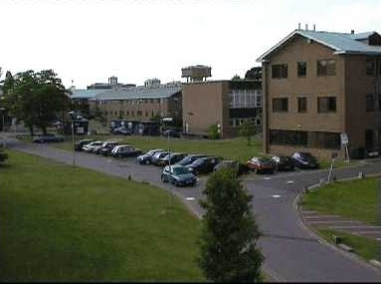 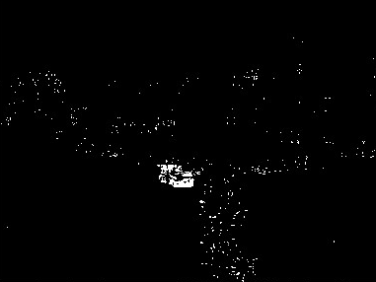

ImageNumber 423 : OriginalImage : ForegroundImage

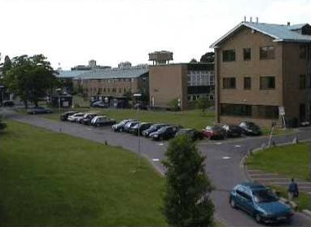 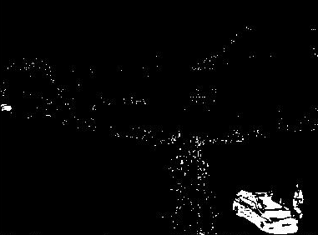

ImageNumber 587 : OriginalImage : ForegroundImage

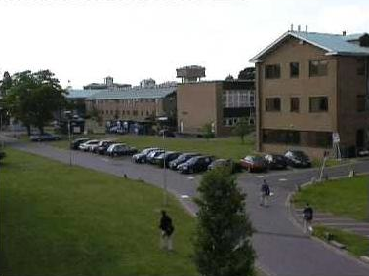 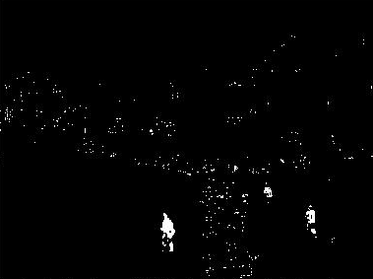

ImageNumber 944 : OriginalImage : ForegroundImage

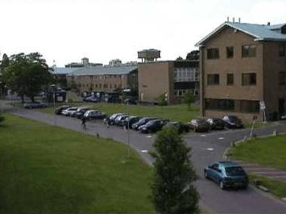 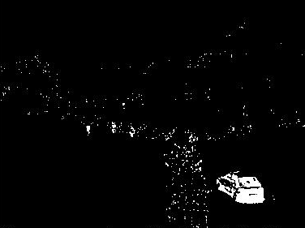

ImageNumber 1753 : OriginalImage : ForegroundImage

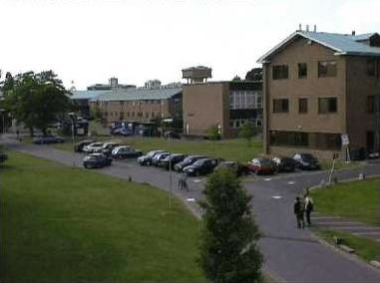 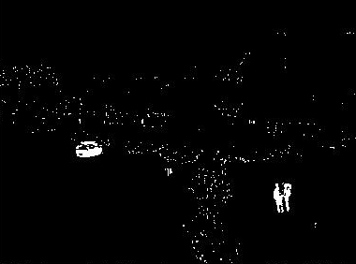

2) Morphological Operations (25%)

a) Apply morphological operations to remove noisy foreground pixels, and to fill possible holes. b) State which operations you chose and why you chose them.

First do open operation, because open operation is doing dilation first then erosion in order to remove noisy foreground pixels.

Then do close operation, which is dilation followed by erosion, this enable us to fill possible hole.

checkCode from ‘Background.m’

% Morphological operation

imgOpen = imopen (show1, strel('disk', 1));

imgClose = imclose (imgOpen, strel('disk', 1));

show2 = imgClose;

figure(1); imshow(img);

figure(2); imshow(show1);

figure(3); imshow(show2);

c) For the same 5 frames you used above, show the output of the morphological operations.

ImageNumber 346 : OriginalImage : ForegroundImage ： AfterMorphology

  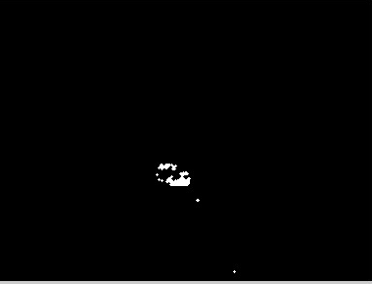

ImageNumber 423 : OriginalImage : ForegroundImage ： AfterMorphology

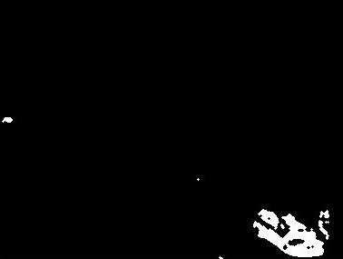

ImageNumber 587 : OriginalImage : ForegroundImage ： AfterMorphology

  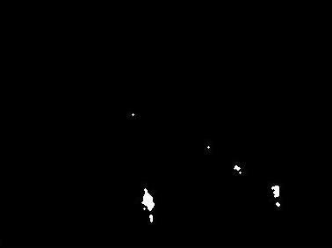

ImageNumber 944 : OriginalImage : ForegroundImage ： AfterMorphology   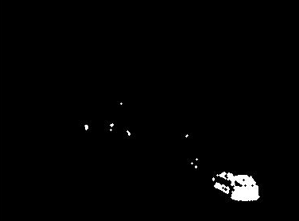

ImageNumber 1753 : OriginalImage : ForegroundImage ： AfterMorphology   